What is Asynchronous Apex (Async Apex)?
An asynchronous process is a process or function that executes a task "in the background" without the user having to wait for the task to finish.

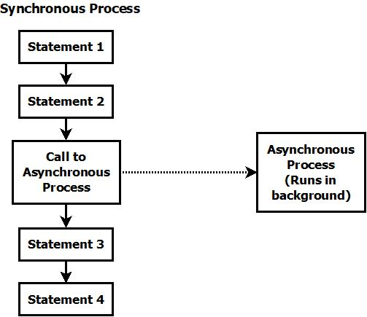

Advantages of Async Apex:
1. Runs in background.
2. Higher governor limits (can process more records)
3. Can be scheduled.
4. Can process more number of records.

Apex offers multiple ways for running your Apex code asynchronously:
1. Future Methods
2. Batch Apex
3. Queueable Apex
4. Scheduled Apex

